Trees: Spring 2015 MT2 Q4c
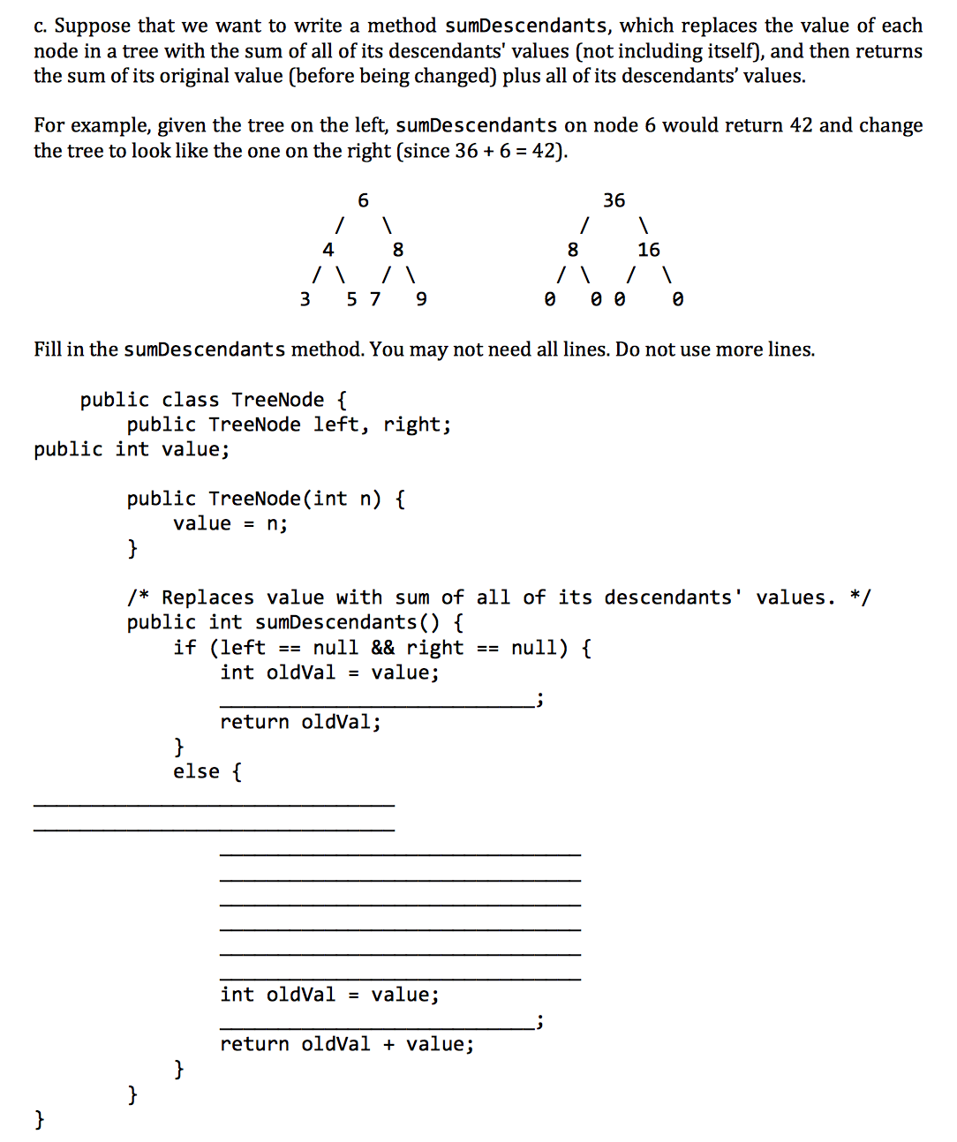
Iterators: Fall 2014 MT1 Q5
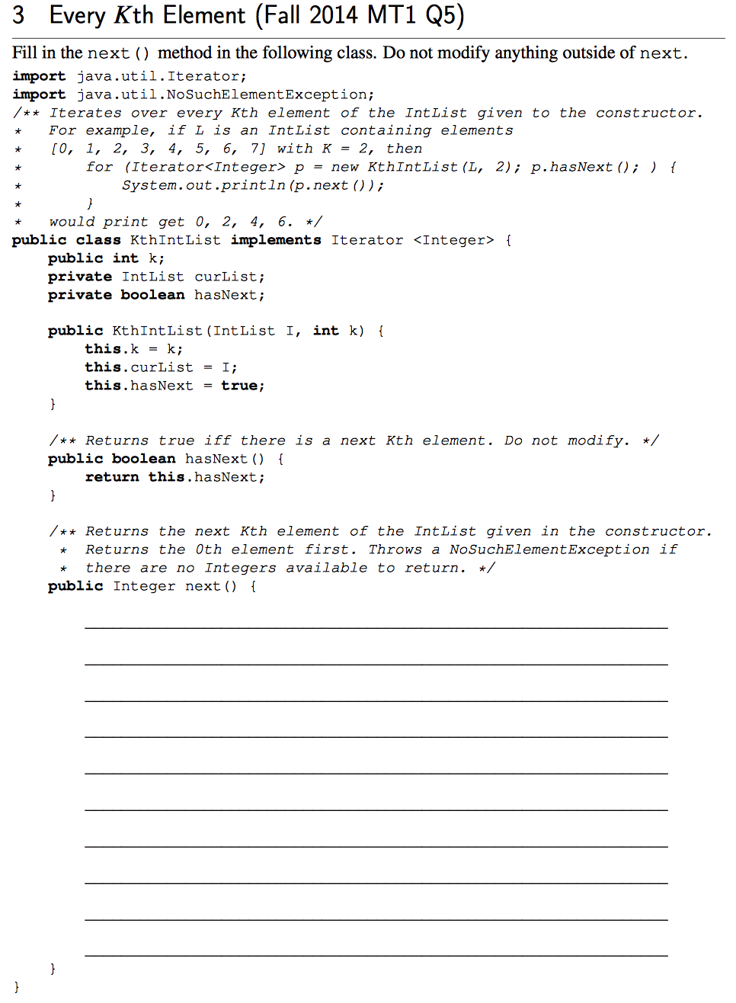
BST: Spring 2016 MT2 Q7
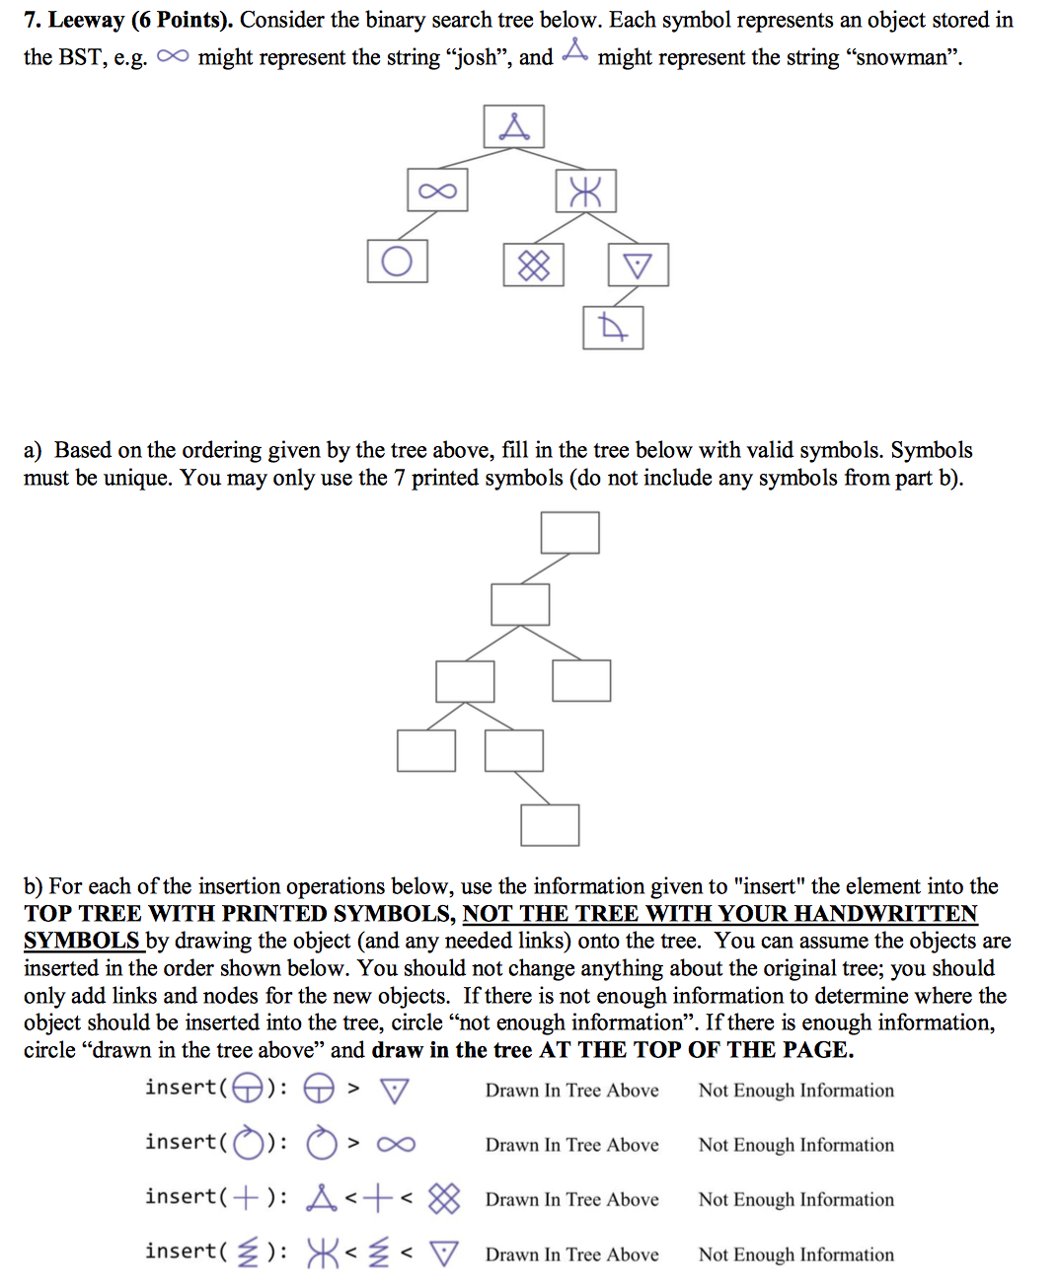
Asymptotics: Spring 2016 MT2 Q9
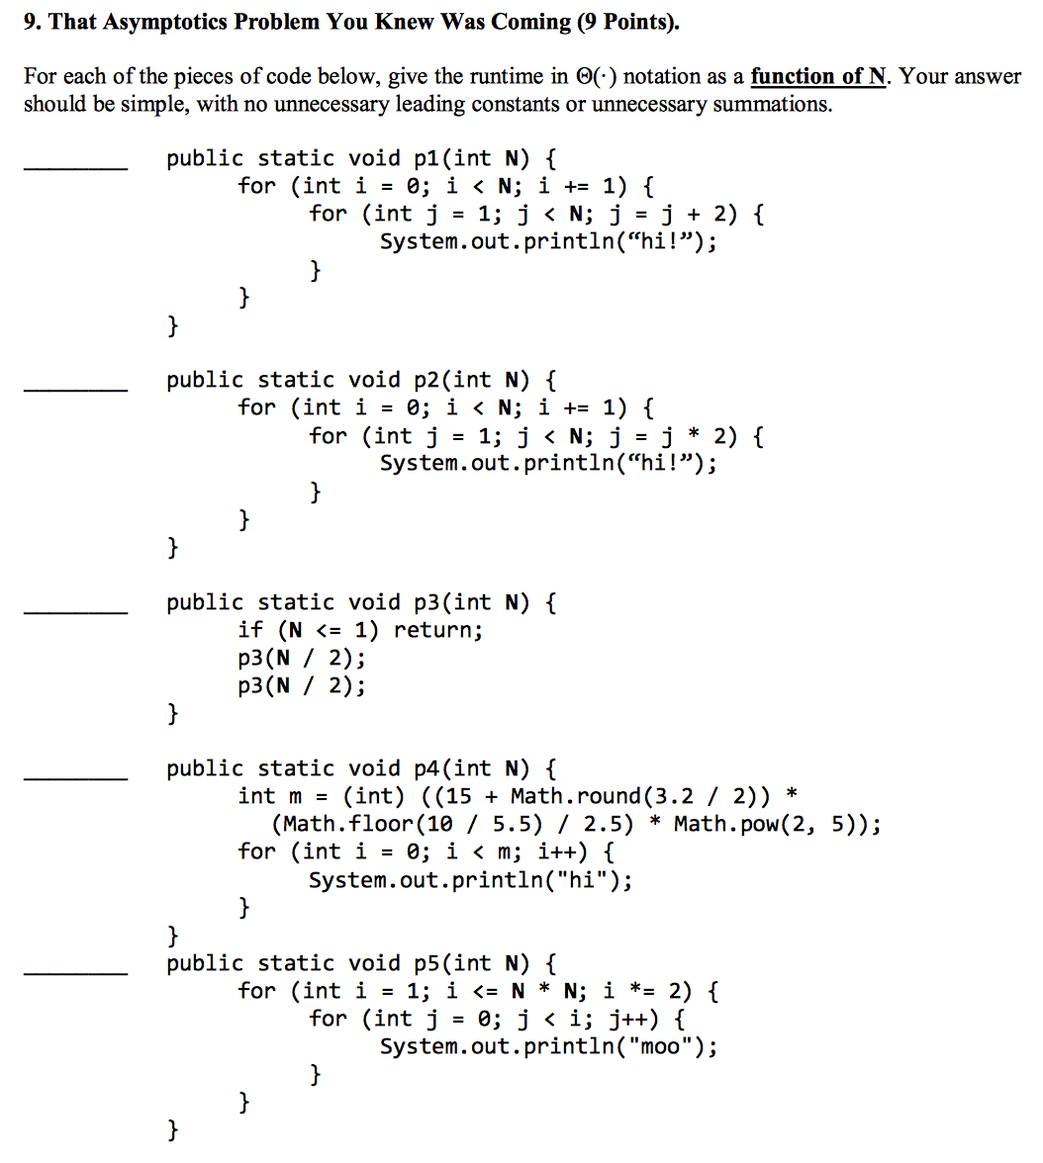

Asymptotics: Spring 2015 MT2 Q5
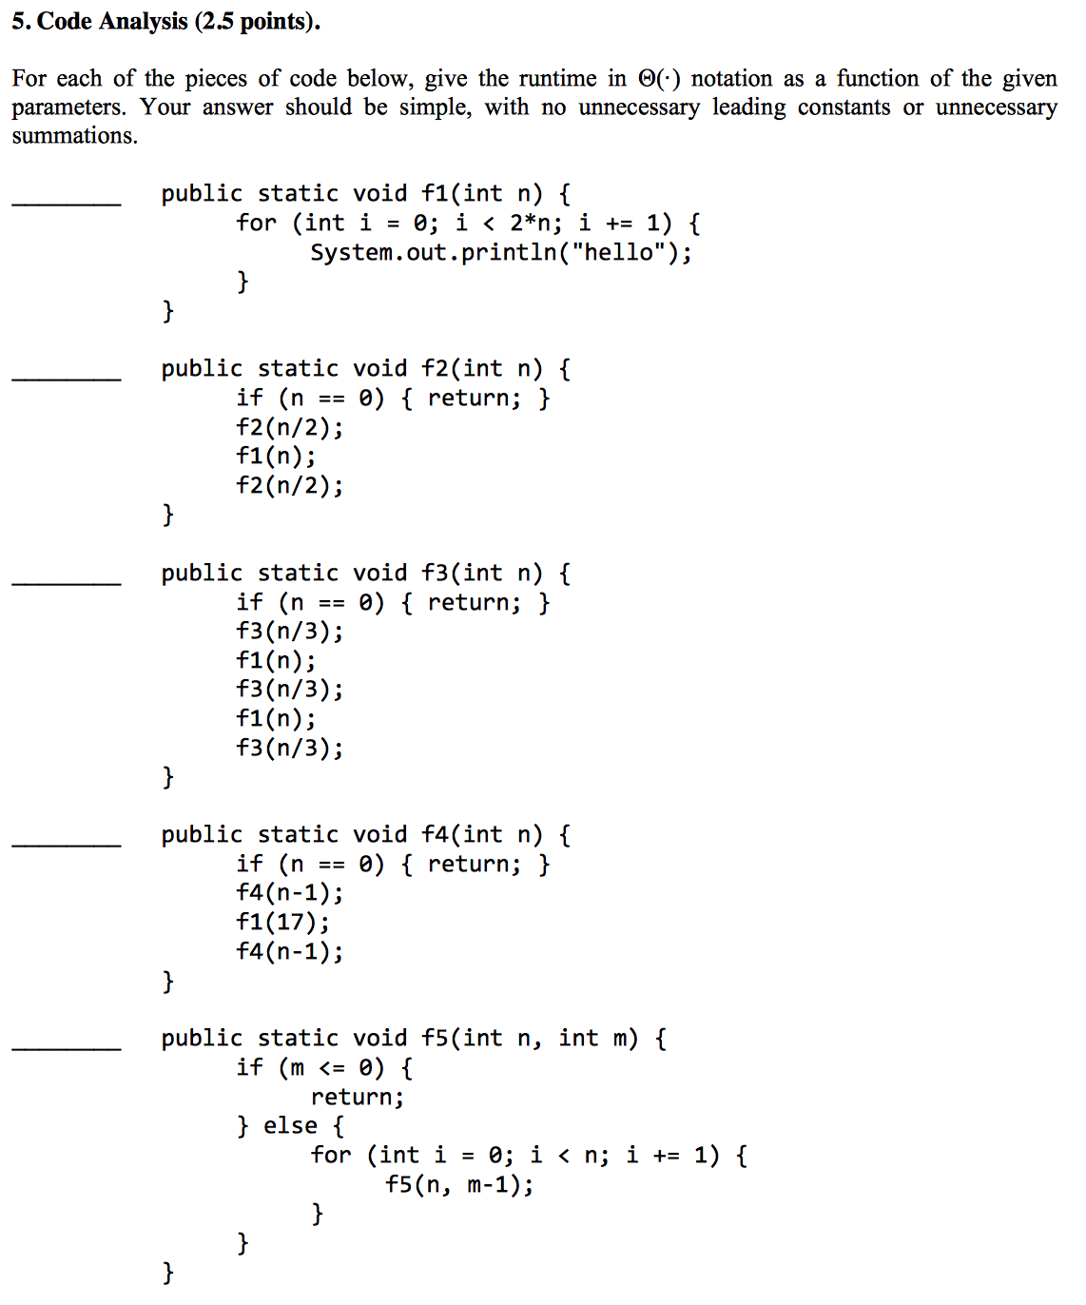

Hashing Runtimes: Fall 2016 MT2 Q3
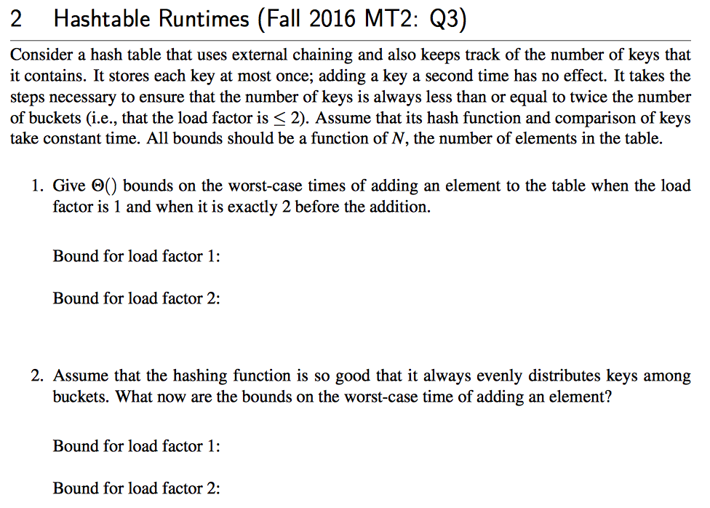
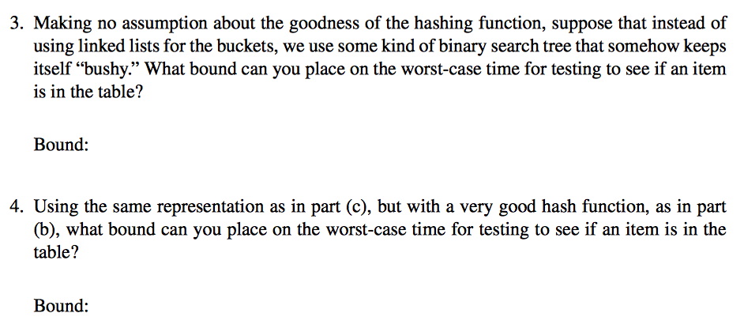

BST/Hash Table: Spring 2016 MT2 Q1
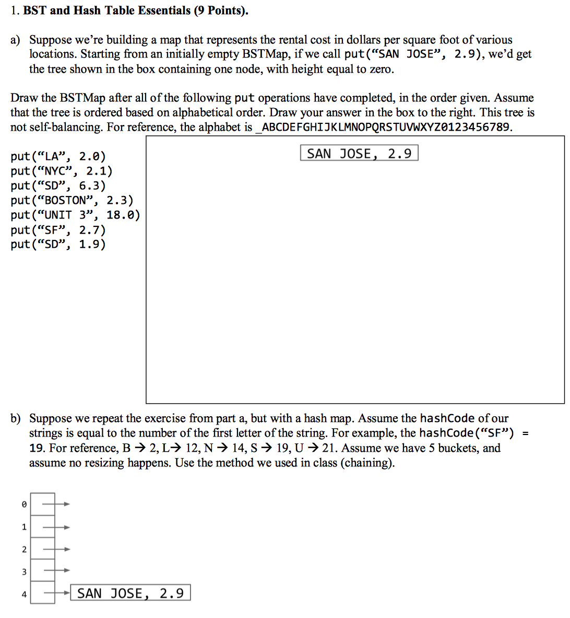
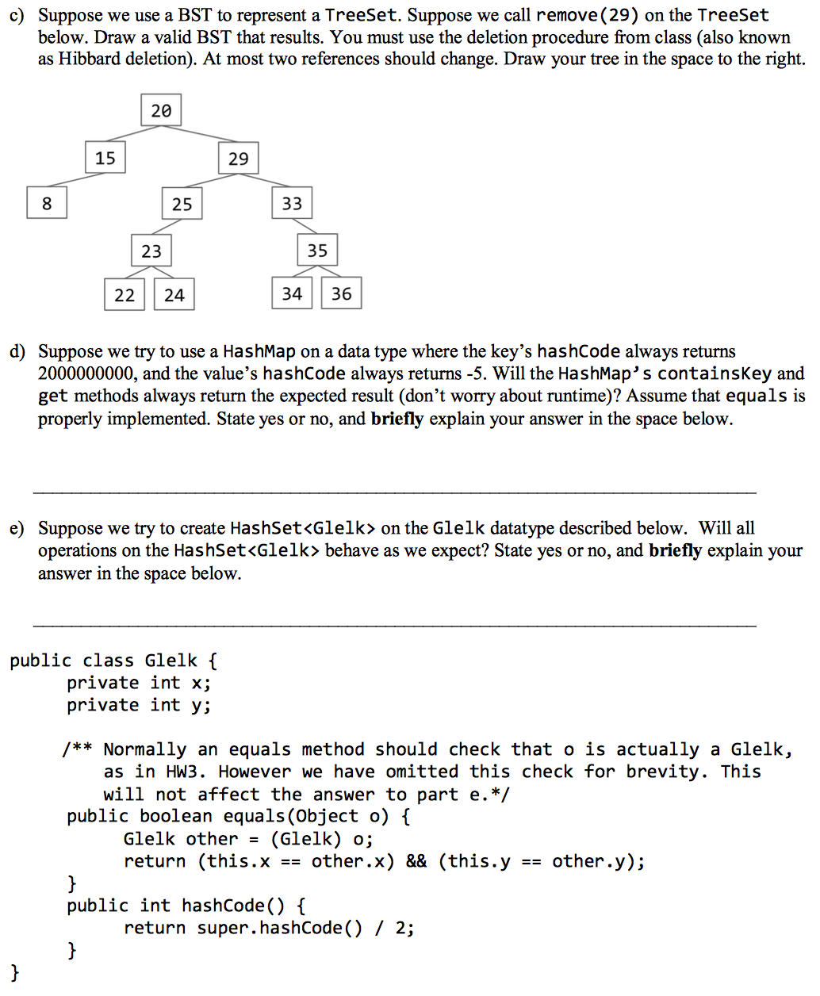
Trees: Summer 2016 MT2 Q7